Exp.No-18
18. Perform Edge detection using Sobel Matrix along Y axis

Aim:
To detect the edges of an image along the Y-axis using the Sobel operator.
Procedure:
- Start the program.
- Import the required library.
- Read the input image (puppy.jpg).
- Convert it into grayscale.
- Apply the Sobel operator along the Y-axis.
- Display the original and output images.
- Save the output image.
- Stop the program.
Program:
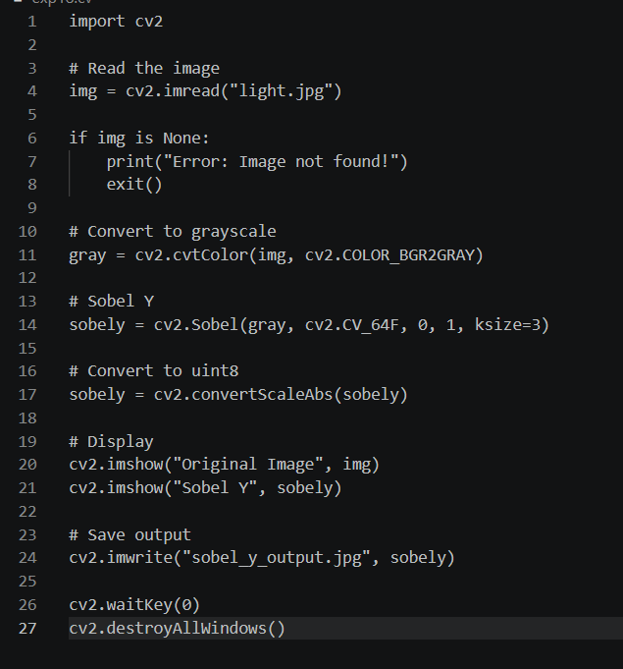
Input:

Output:

Result:
The edges along the Y-axis were successfully detected using the Sobel operator.

